**🎛️ DSP Stack Visualization & Grouping UX**

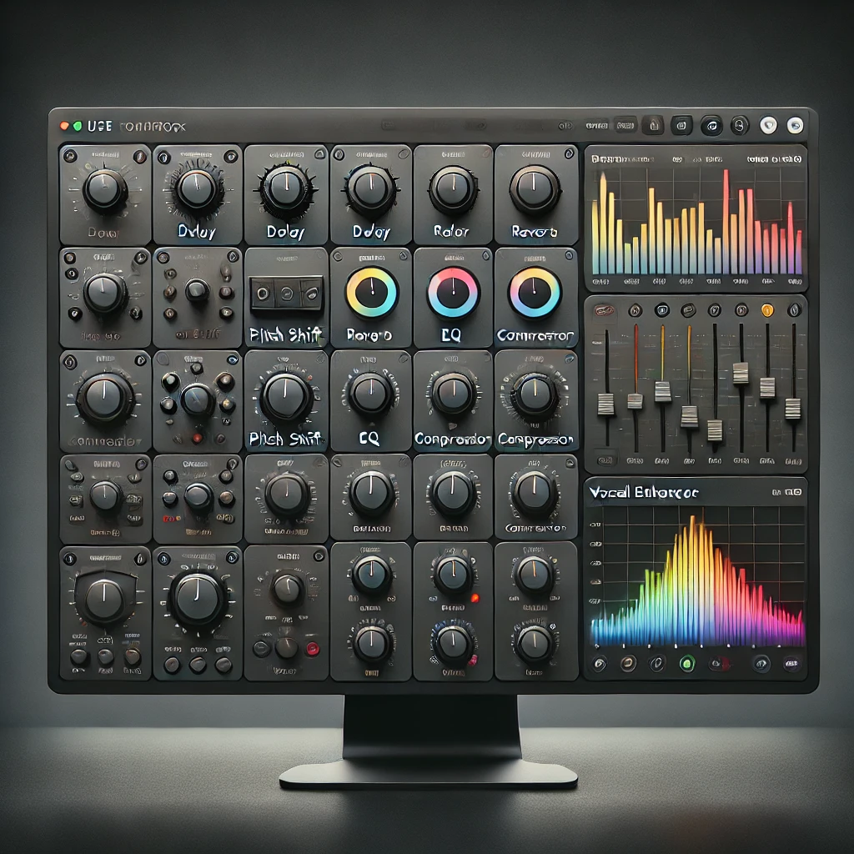

**Core UI Layout Concept**

* 🧱 **Vertical List of Boxes (Your Effect Stack)**
  + Each box = one **effect module** or **group**
  + Signal flows **top to bottom**
  + Stack order = DSP processing order
  + **Arrows** or **drag handles** allow reorder
  + **Icons/buttons** for:
    - Expand common controls inline
    - Open full control panel
    - Bypass
    - Solo
    - Duplicate
    - Delete

**🧩 Group Structure: Collapsible Containers**

* A **Group** is a container for:
  + One or more **effect modules**
  + OR nested **groups**
* Groups are:
  + Collapsible (click to expand/collapse)
  + Nameable (e.g., “Warmth Stack”, “Vocal Enhancer”)
  + Reorderable like any module
  + Exportable as .dspchain or part of a .dspproj

**✅ Group Controls:**

* Rename
* Collapse/Expand
* Export as standalone chain
* Convert to local copy / duplicate
* Nested display (with slight indent or highlight for hierarchy)

**🖼️ Minimal Inline View vs. Full View**

* **Collapsed View:**
  + Shows only name, basic info (e.g., module count)
  + Has quick controls (bypass, drag, menu)
* **Expanded View:**
  + Shows the most commonly used parameters as sliders or knobs
  + Ideal for fast tweaks during playback
* **Full Panel View:**
  + Opens in bottom or side panel
  + All parameters, macros, meters, routing for that module/group

**🧮 Exporting Options**

* Select any **single effect** or **group**
* Right-click → **Export as Reusable Chain**
  + Saves as .dspchain or .dspgroup
  + Can be loaded into any other project
* Optional: export nested chains with flattening or retain hierarchy

**📦 Visual Feedback**

* Color bands or headers for groups
* Group nesting shown with slight indentation
* Hover effects and click-feedback on arrows and drag handles
* Icon for “linked group” (if it's a reference, not local copy)

**🧠 UX Philosophy**

* **Visual simplicity**: Let the user focus on stacking and shaping
* **Structured freedom**: You can group, ungroup, move, tweak anything
* **No mystery**: You *see* what you’re hearing